Ideation Phase
Empathize & Discover

Date | 25 February 2026
Team ID | LTVIP2026TMIDS81684
Project Name | Calculating Family Expenses using ServiceNow
Maximum Marks | 4 Marks

Empathy Map Canvas:
An empathy map is a simple, easy-to-digest visual that captures knowledge about a user’s behaviours and attitudes.

It is a useful tool to helps teams better understand their users.
Creating an effective solution requires understanding the true problem and the person who is experiencing it. The exercise of creating the map helps participants consider things from the user’s perspective along with his or her goals and challenges.
Example:
e
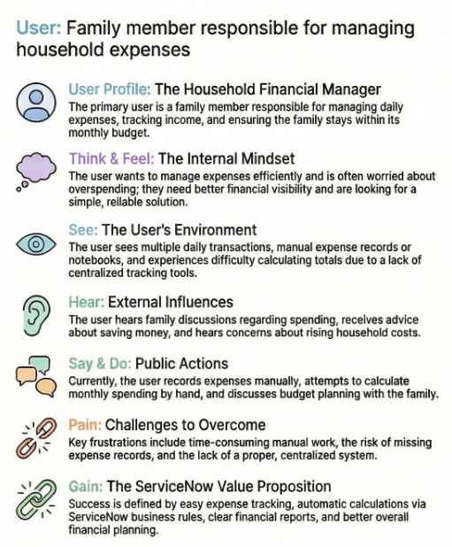

Reference: https://www.mural.co/templates/empathy-map-canvas
Example: Food Ordering & Delivery Application

Empathy Map for Calculating Family Expenses using ServiceNow
User: Family member responsible for managing household expenses
Think & Feel:
• Wants to manage expenses efficiently
• Worried about overspending
• Needs better financial visibility
• Looking for a simple solution
See:
• Multiple daily transactions
• Manual expense records
• Difficulty calculating totals
• Lack of centralized tracking tools
Hear:
• Family discussions about expenses
• Advice about saving money
• Concerns about rising costs
Say & Do:
• Records expenses manually
• Calculates monthly spending
• Discusses budget with family
Pain:
• Time-consuming manual work
• Missing expense records
• No proper system
Gain:
• Easy expense tracking
• Automatic calculations
• Clear financial reports
• Better financial planning

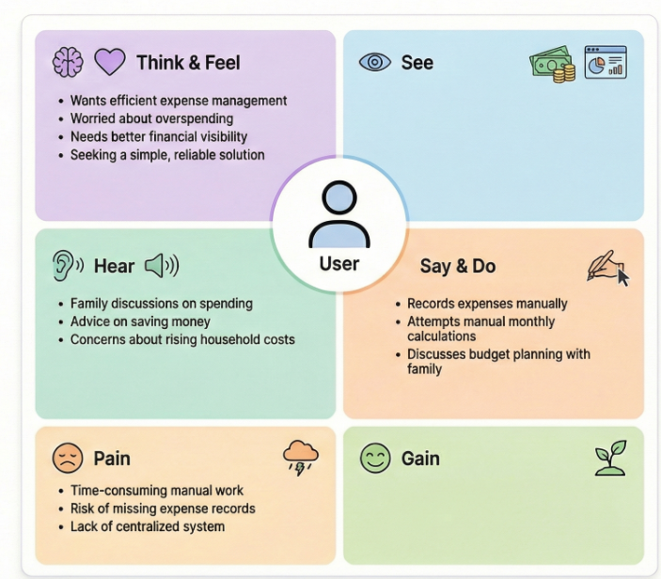0



